**Disputes Project**

**Requirements:**

**1. Installing Tesseract:**

* To install tesseract, Open the following link and download .exe file 🡪 [Home](https://github.com/UB-Mannheim/tesseract/wiki)
* During installation, copy path of destination folder (screenshot of installation wizard is attached.)  
    
  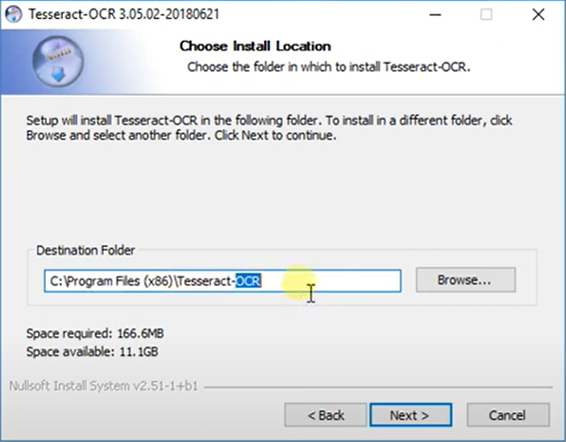
* Once installation is done, Tesseract is to be included in the system environment variables path.
* Include the path of destination folder (path you copied) in environment variables.
* You can check if it’s successfully installed by running this command in cmd: *tesseract -v.*

**2. Installing Poppler:**

* To install Poppler, go to the requirement folder and extract Poppler into C:\Program Files.
* After extracting add C:\Program Files\poppler-23.07.0\Library\bin to your system path.

**3. Virtual Environment:**

* To run script a virtual environment is to be created.
* Install module ‘virtualenv’ by running *pip install virtualenv* in cmd.
* After the module is installed, go to the project folder in cmd, and run *virtualenv venv* this will create a separate environment for the project.
* To activate the virtual environment, type *venv\Scripts\activate* in cmd.

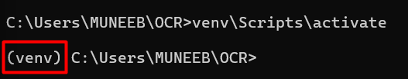

* You’ll see the virtual environment is activated, you can install all modules required within this virtual environment and it won’t affect your global modules.
* To install all requirements, navigate to resources > requirements folder and run command:   
  *pip install -r requirements.txt*

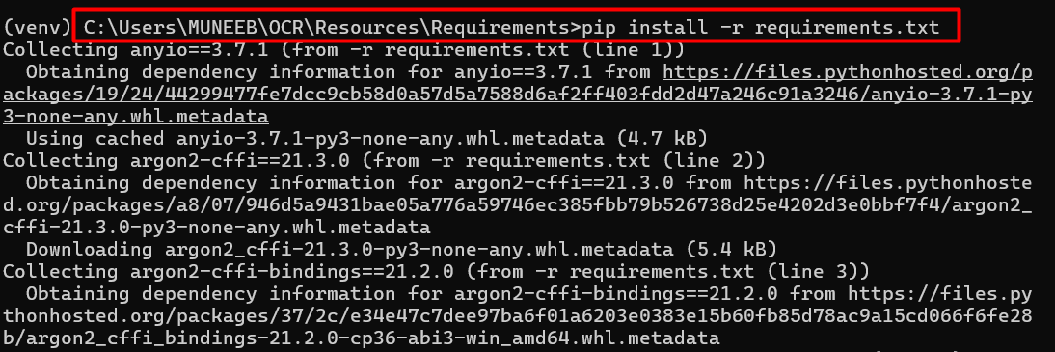

This will install all required modules for project.